In the following example we assume that the user has the following data:
E-mail: test@hti.pl
Outgoing SMTP mail server: poczta.hti.pl
Incoming mail server IMAP: poczta.hti.pl
Username in the system: test@hti.pl
We start the mail program, then select Settings and our account from the menu, and then scroll to the server settings and select incoming mail. Configure the following example and confirm with the "Done" button:

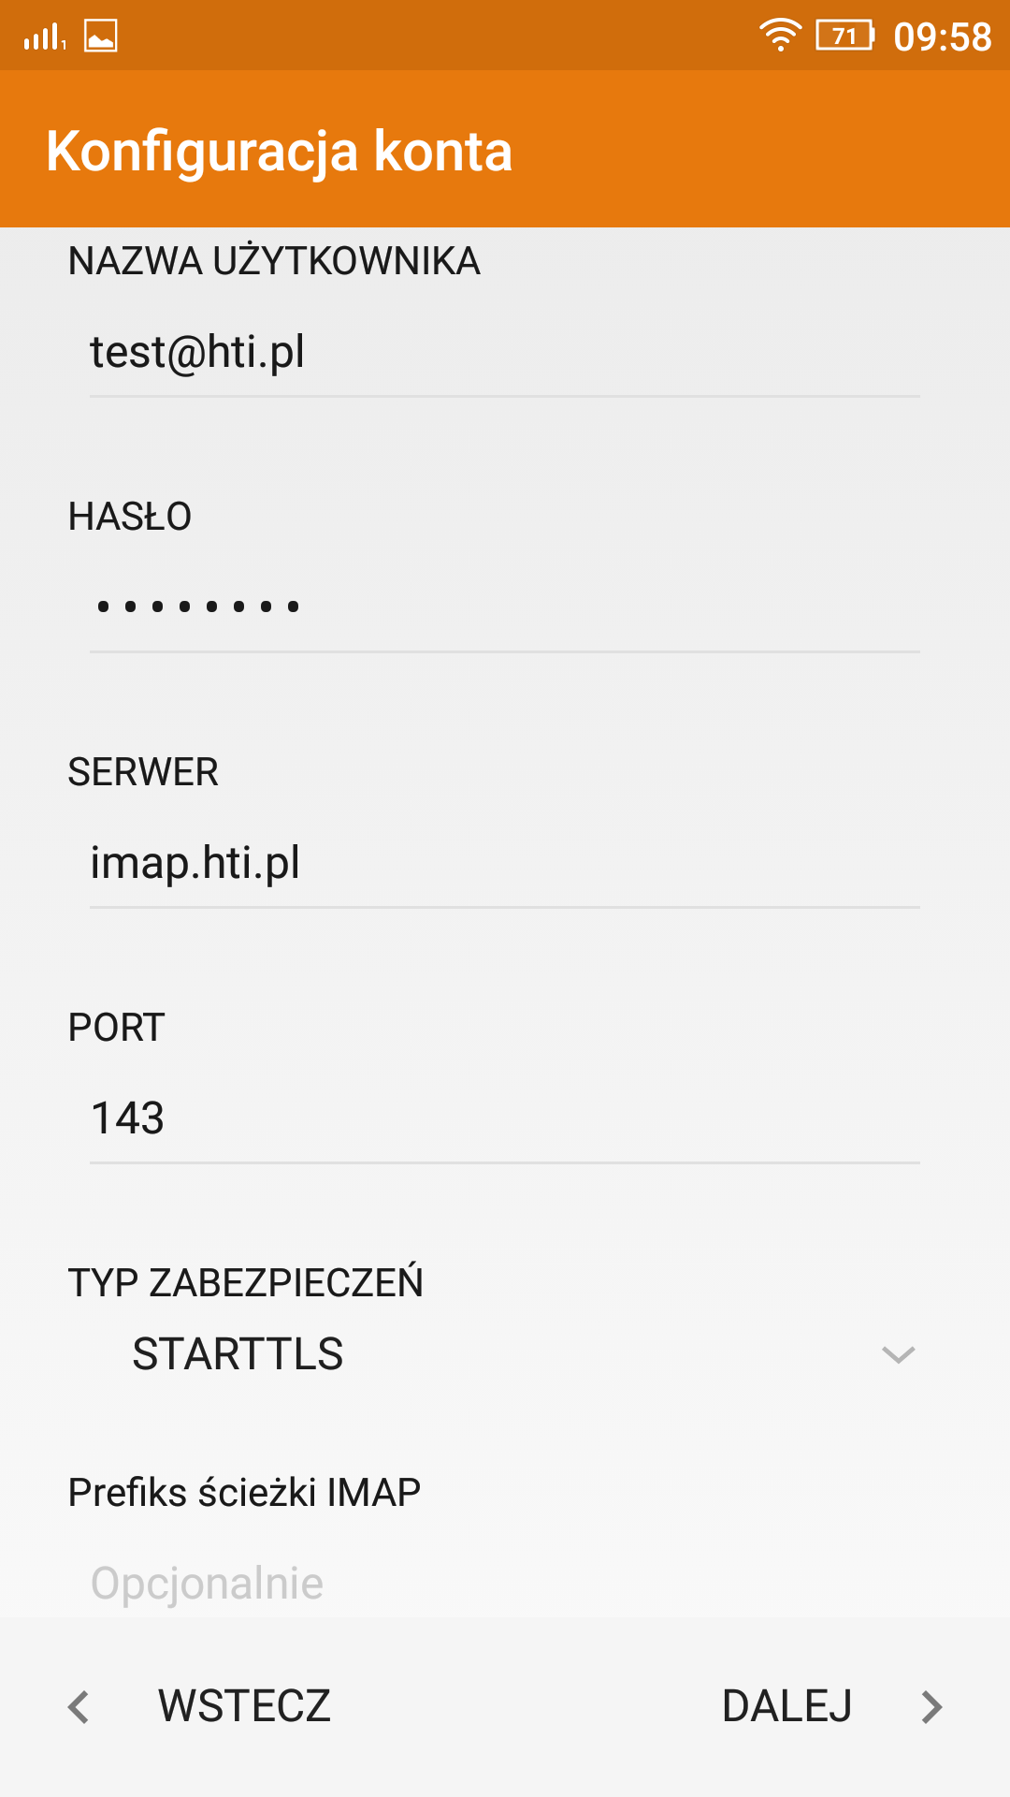

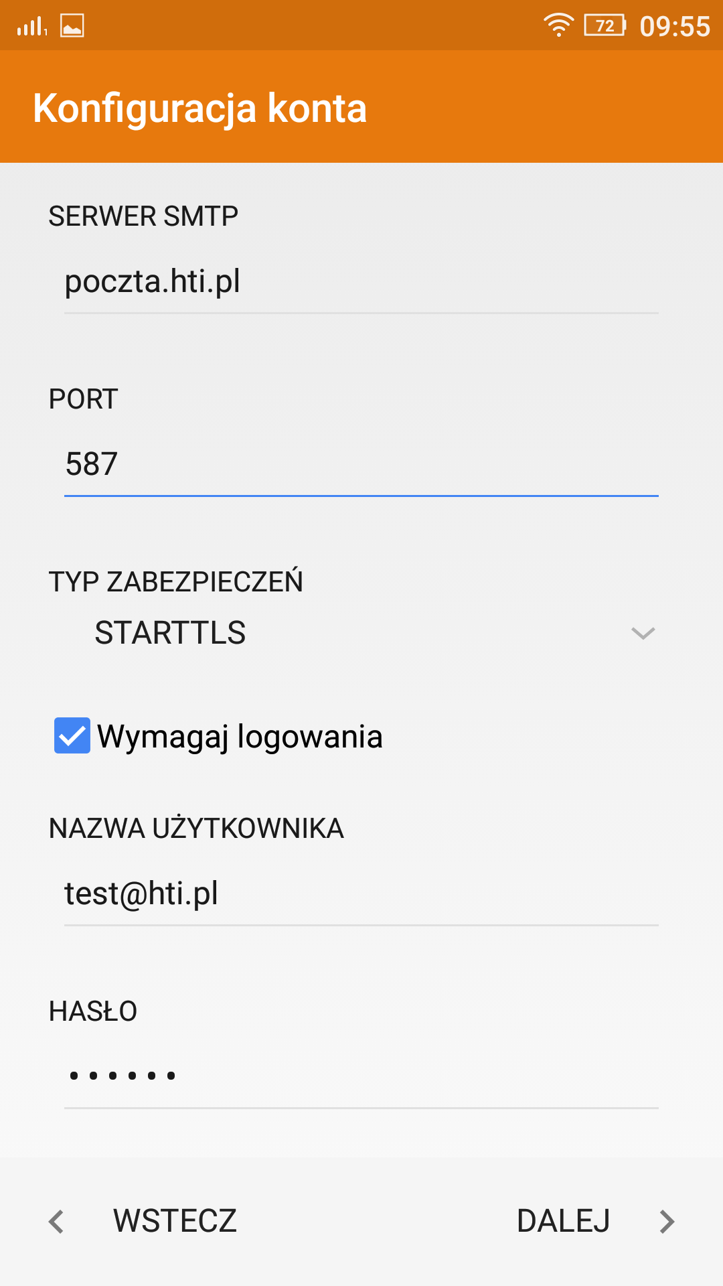
Then select the outgoing mail and configure as follows, press "Done" button:

The IMAP account is now configured and ready to work.

