In the following example we assume that the user has the following data:
E-mail address: test@hti.pl
Outgoing mail server SMTP: poczta.hti.pl
Incoming mail server IMAP: poczta.hti.pl
User name: test@hti.pl

After program starts select Tools from Menu and click E-Mail Accounts. Select your account from list and click change:

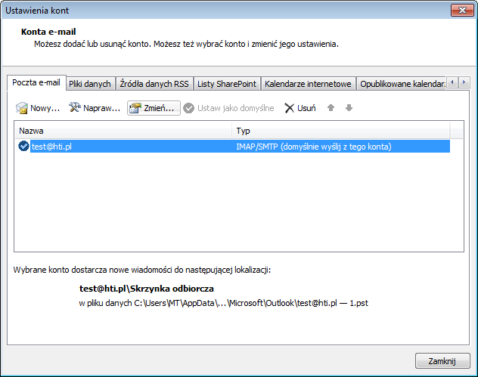

Set your settings as show below:

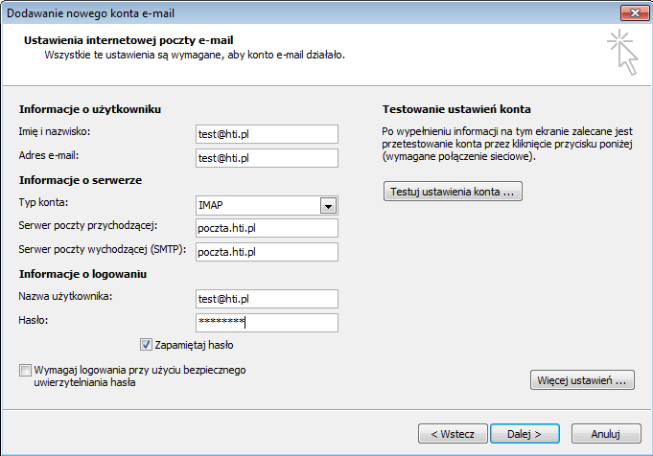

Click More settings and select Outgoing server tab. Set your settings as show below:

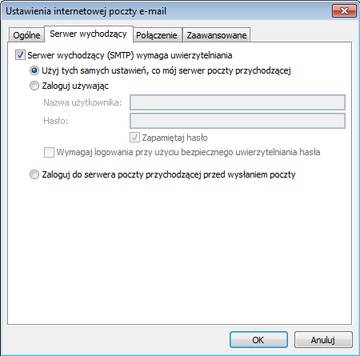
Select Advanced Tab and set your settings as show below:

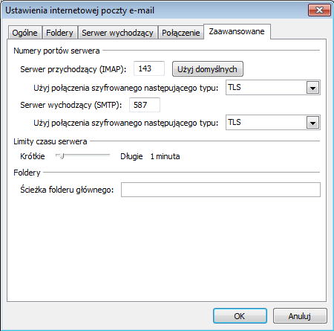

Click OK and return to account configuration window. Click Next.

