In the following example we assume that the user has the following data:
E-mail address: test@hti.pl
Outgoing mail server SMTP: poczta.hti.pl
Incoming mail server IMAP: poczta.hti.pl
User name: test@hti.pl

After program start select Accounts from Tools Tab, choose your account from list and set your settings as show below:
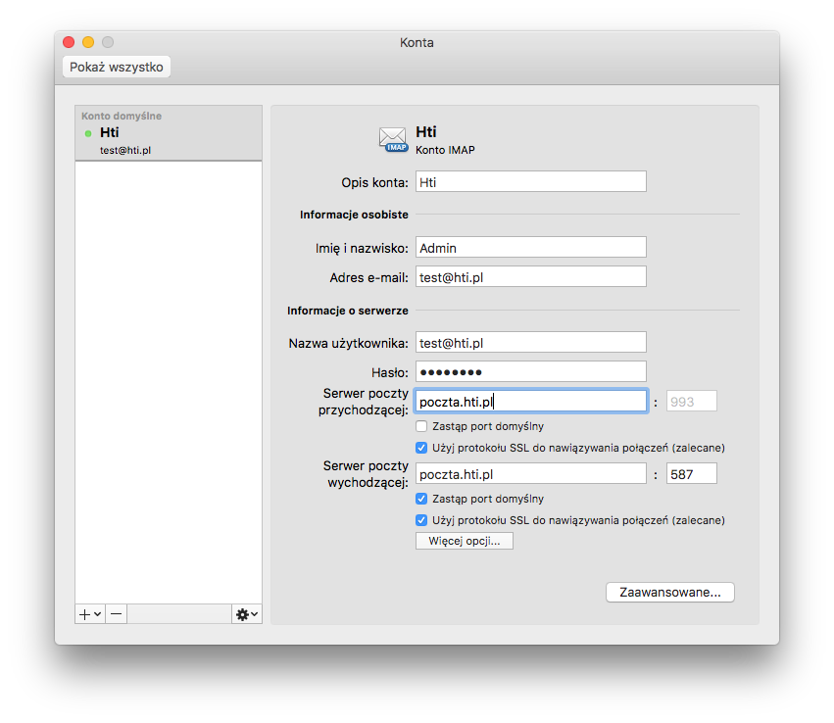

Click Advanced and check that „IMAP main folder” field is blank:


