In the following example we assume that the user has the following data:
E-mail address: test@hti.pl
Outgoing mail server SMTP: poczta.hti.pl
Incoming mail server POP3: poczta.hti.pl
User name: test@hti.pl

Click on three parallel lines on right side:
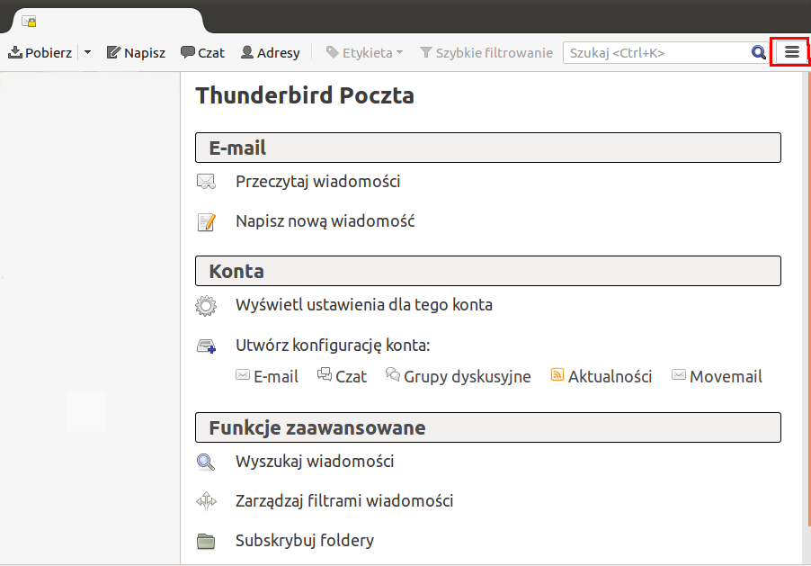

Select preference and click account configuration

Select Outgoing Mail from left side menu. Choose account to change and click edit
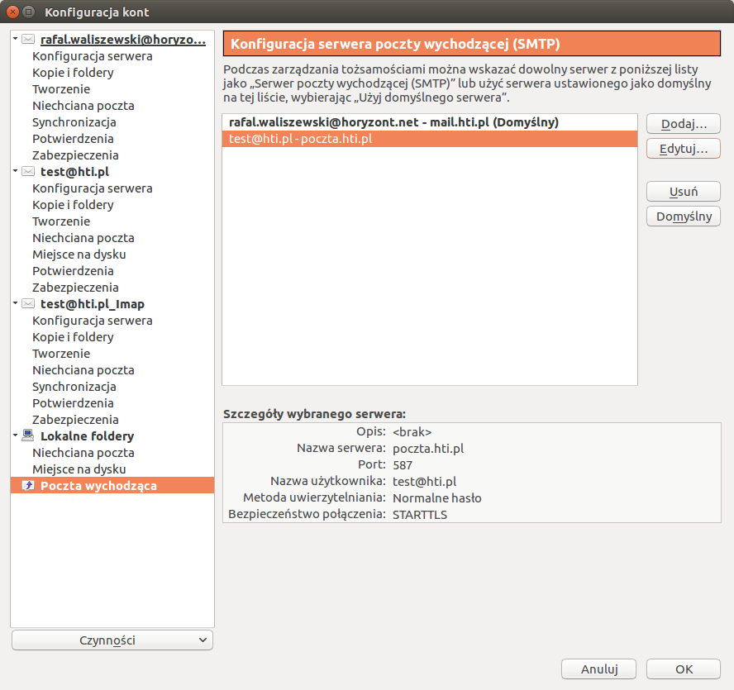

Set your settings as show below:

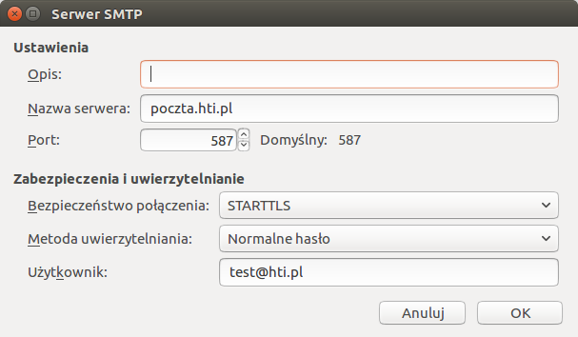
To save changes click OK

In account configuration window, select your account and click server configuration. Set your settings as show below:

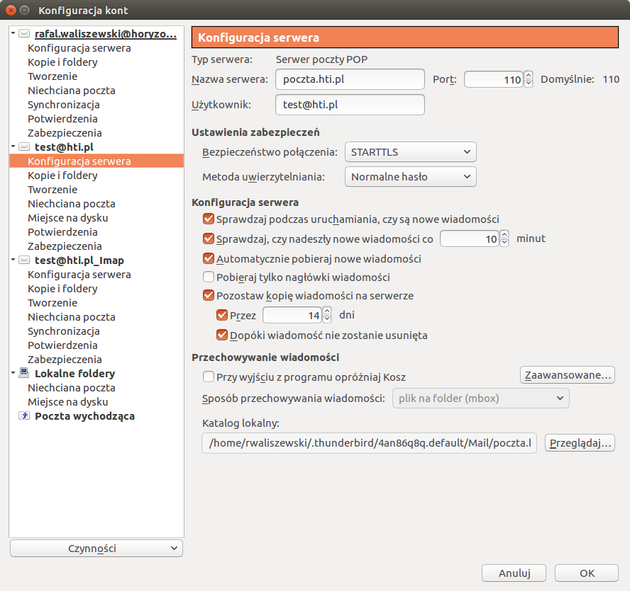
To save changes click OK

