In the following example we assume that the user has the following data:
E-mail address: test@hti.pl
Outgoing mail server SMTP: poczta.hti.pl
Incoming mail server POP3: poczta.hti.pl
User name: test@hti.pl

After program starts select Account Tab, mark account to change and click properties.
Select Outgoing server tab. Set your settings as show below:
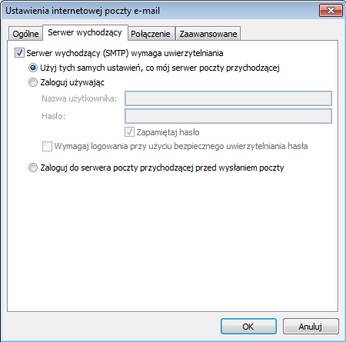

Select Advanced Tab and set your settings as show below:

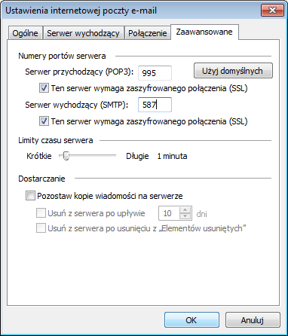

Click OK

